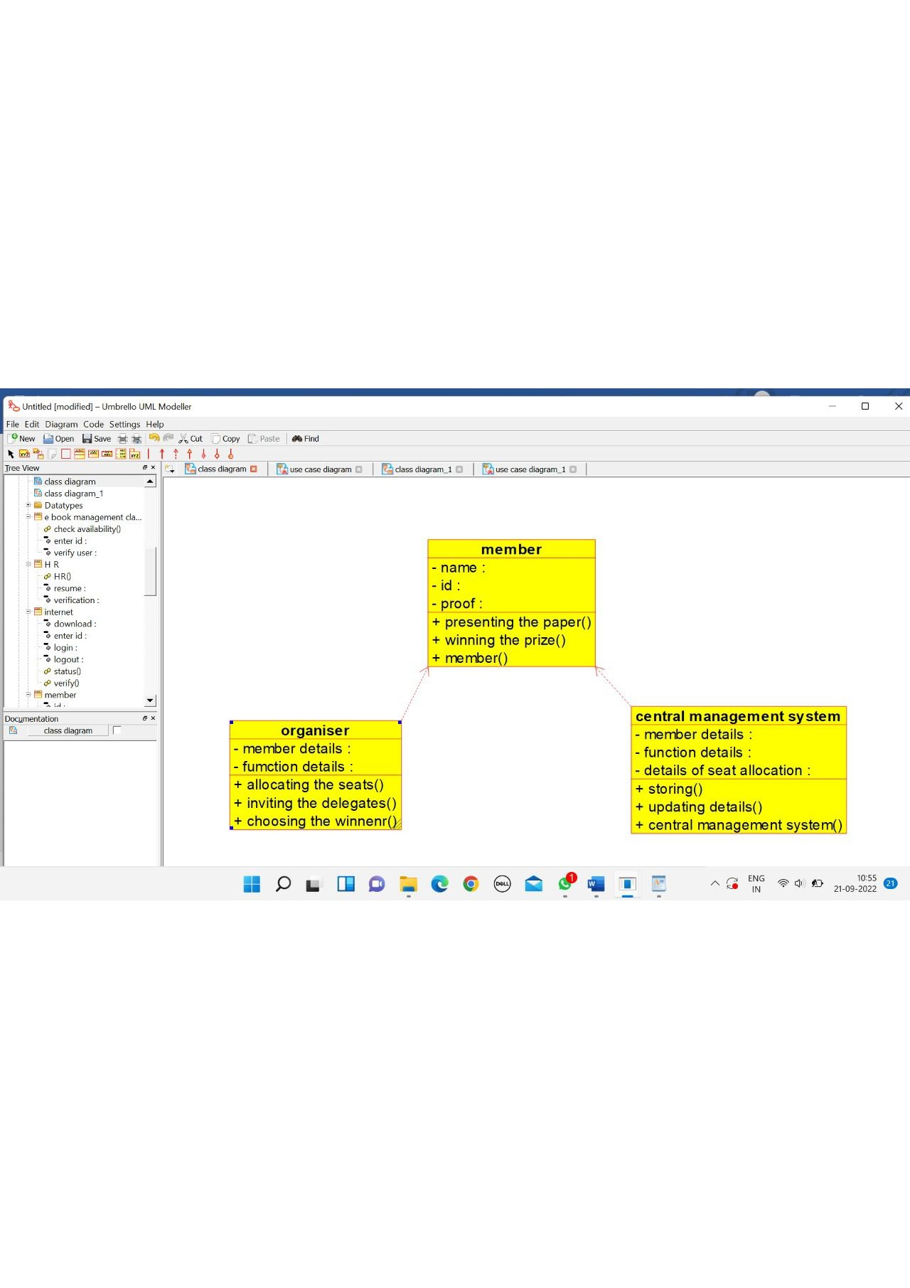

ORGANISER

/**

* Class organiser

*/

public class organiser {

//

// Fields

//

private void member_details;

private void fumction_details;

//

// Constructors

//

public organiser () { };

//

// Methods

//

//

// Accessor methods

//

/**

* Set the value of member_details

* @param newVar the new value of member_details

*/

private void setMember_details (void newVar) {

member_details = newVar;

}

/**

* Get the value of member_details

* @return the value of member_details

*/

private void getMember_details () {

return member_details;

}

/**

* Set the value of fumction_details

* @param newVar the new value of fumction_details

*/

private void setFumction_details (void newVar) {

fumction_details = newVar;

}

/**

* Get the value of fumction_details

* @return the value of fumction_details

*/

private void getFumction_details () {

return fumction_details;

}

//

// Other methods

//

/**

*/

public void allocating_the_seats()

{

}

/**

*/

public void inviting_the_delegates()

{

}

/**

*/

public void choosing_the_winnenr()

{

}

MEMBER

/**

* Class member

*/

public class member {

//

// Fields

//

private void name;

private void id;

private void proof;

//

// Constructors

//

public member () { };

//

// Methods

//

//

// Accessor methods

//

/**

* Set the value of name

* @param newVar the new value of name

*/

private void setName (void newVar) {

name = newVar;

}

/**

* Get the value of name

* @return the value of name

*/

private void getName () {

return name;

}

/**

* Set the value of id

* @param newVar the new value of id

*/

private void setId (void newVar) {

id = newVar;

}

/**

* Get the value of id

* @return the value of id

*/

private void getId () {

return id;

}

/**

* Set the value of proof

* @param newVar the new value of proof

*/

private void setProof (void newVar) {

proof = newVar;

}

/**

* Get the value of proof

* @return the value of proof

*/

private void getProof () {

return proof;

}

//

// Other methods

//

/**

*/

public void presenting_the_paper()

{

}

/**

*/

public void winning_the_prize()

{

}

/**

*/

public void member()

{

}

CENTRAL MANAGEMENT SYSTEM

/**

* Class central_management

*/

public class central_management {

//

// Fields

//

private void train_name;

private void passenger_name;

//

// Constructors

//

public central_management () { };

//

// Methods

//

//

// Accessor methods

//

/**

* Set the value of train_name

* @param newVar the new value of train_name

*/

private void setTrain_name (void newVar) {

train_name = newVar;

}

/**

* Get the value of train_name

* @return the value of train_name

*/

private void getTrain_name () {

return train_name;

}

/**

* Set the value of passenger_name

* @param newVar the new value of passenger_name

*/

private void setPassenger_name (void newVar) {

passenger_name = newVar;

}

/**

* Get the value of passenger_name

* @return the value of passenger_name

*/

private void getPassenger_name () {

return passenger_name;

}

//

// Other methods

//

/**

*/

public void reservation()

{

}

/**

*/

public void cancellation()

{

}

/**

*/

public void status()

{

}

/**

*/

public void login()

{

}

/**

*/

public void central_management()

{

}

}

